# **Proposal for AAST VVB IT Infrastructure**

## **Vision**

To establish AAST as a Validation/Verification Body (VVB) equipped with a robust IT infrastructure that ensures operational efficiency, stakeholder satisfaction, and compliance with international standards. By leveraging advanced technologies, including **AI, satellite imagery, IoT, and APIs**, the platform will enable AAST to independently verify and validate carbon projects while ensuring scalability and transparency.

## **Goals**

The following goals guide the development of the AAST VVB IT infrastructure, ensuring alignment with the program's objectives:

### **1. Ensure Operational Efficiency**

* Transition from paper-based processes to fully digital workflows.
* Automate and streamline submission, validation, and reporting tasks.
* Reduce verification time and administrative overhead.

### **2. Improve Accuracy and Consistency**

* Leverage AI for anomaly detection and document validation.
* Use IoT and satellite imagery for real-time and remote project verification, especially for land-use and emissions monitoring.
* Ensure high consistency and quality in methodology validation.

### **3. Strengthen Stakeholder Experience**

* Provide stakeholders with user-friendly tools for data submission and monitoring.
* Develop APIs for integration with external tools used by stakeholders.
* Enable real-time feedback and reporting to improve compliance.

### **4. Expand Market Leadership**

* Build capabilities for emerging methodologies and advanced verification needs.
* Create seamless integration with carbon market systems to streamline compliance reporting.
* Establish AAST as a trusted verification partner in regional and global markets.

## **Key Performance Indicators (KPIs)**

|  |  |  |
| --- | --- | --- |
| **Category** | **Key Metrics** | **Target** |
| **Operational Efficiency** | - Verification Cycle Time.  - Data Curation and Processing Time.  - Auditor Utilization. | Complete verifications faster while optimizing auditor and staff workloads. |
| **Accuracy** | - Data Accuracy.  - Methodology Consistency | Improve data validation and ensure alignment with ISO standards across similar projects. |
| **Stakeholder Experience** | - Stakeholder Compliance and Satisfaction. | Simplify the submission process, reduce feedback loops, and enhance user experience. |
| **Digital Presence** | - Website Traffic. - Stakeholder Onboarding | Ensure the website serves as an effective marketing, educational, and onboarding platform. |
| **Market Leadership** | ? | ? |

## **Proposed Solutions**

The infrastructure will be implemented in three phases, combining data management, AI, satellite/IoT integration, and automation tools.

### **Phase 1: Foundational IT System (0–6 Months)**

#### **Key Deliverables**

1. **SaaS Data Management**
   1. Centralized platform for storing project data, documents, and audit trails.
   2. Secure database with role-based access controls.
2. **Structured Data Submission**
   1. Numeric forms for emissions input (e.g., kWh, fuel use).
   2. CSV/Excel uploads for batch data submission.
   3. APIs for stakeholders to programmatically submit or retrieve data.
3. **AI-Powered Anomaly Detection** 
   1. Deploy **AI models** to detect anomalies in numeric data (e.g., unusually high emissions) as a validation process.
   2. Provide stakeholders with flagged issues and suggested corrections.
4. **Role-Based Dashboards**
   1. **Stakeholders**: Submit data, track project progress, and view compliance feedback.
   2. **Auditors**: Review submissions, validate anomalies, and flag issues.
   3. **Administrators**: Monitor system performance, generate reports, and oversee compliance.
5. **Automated Reporting Tools**
   1. Generate reports in **PDF, Excel, or CSV formats** including compliance summaries and visualizations (bar charts, pie charts, etc.).
6. **Compliance Tools**
   1. Maintain a complete **audit trail** of verification decisions.
   2. Align quality management workflows with ISO 14001 and other standards.
7. **Website Development**
   1. **Landing Pages**: Highlight services, methodologies, and stakeholder benefits.
   2. **Blogs and News**: Publish articles on carbon markets, methodologies, and AAST’s thought leadership.
   3. **Educational Material**: Provide guides, videos, and infographics on carbon project verification and compliance.
   4. **Stakeholder Portal**: Allow stakeholders to log in, track project progress, and access resources.

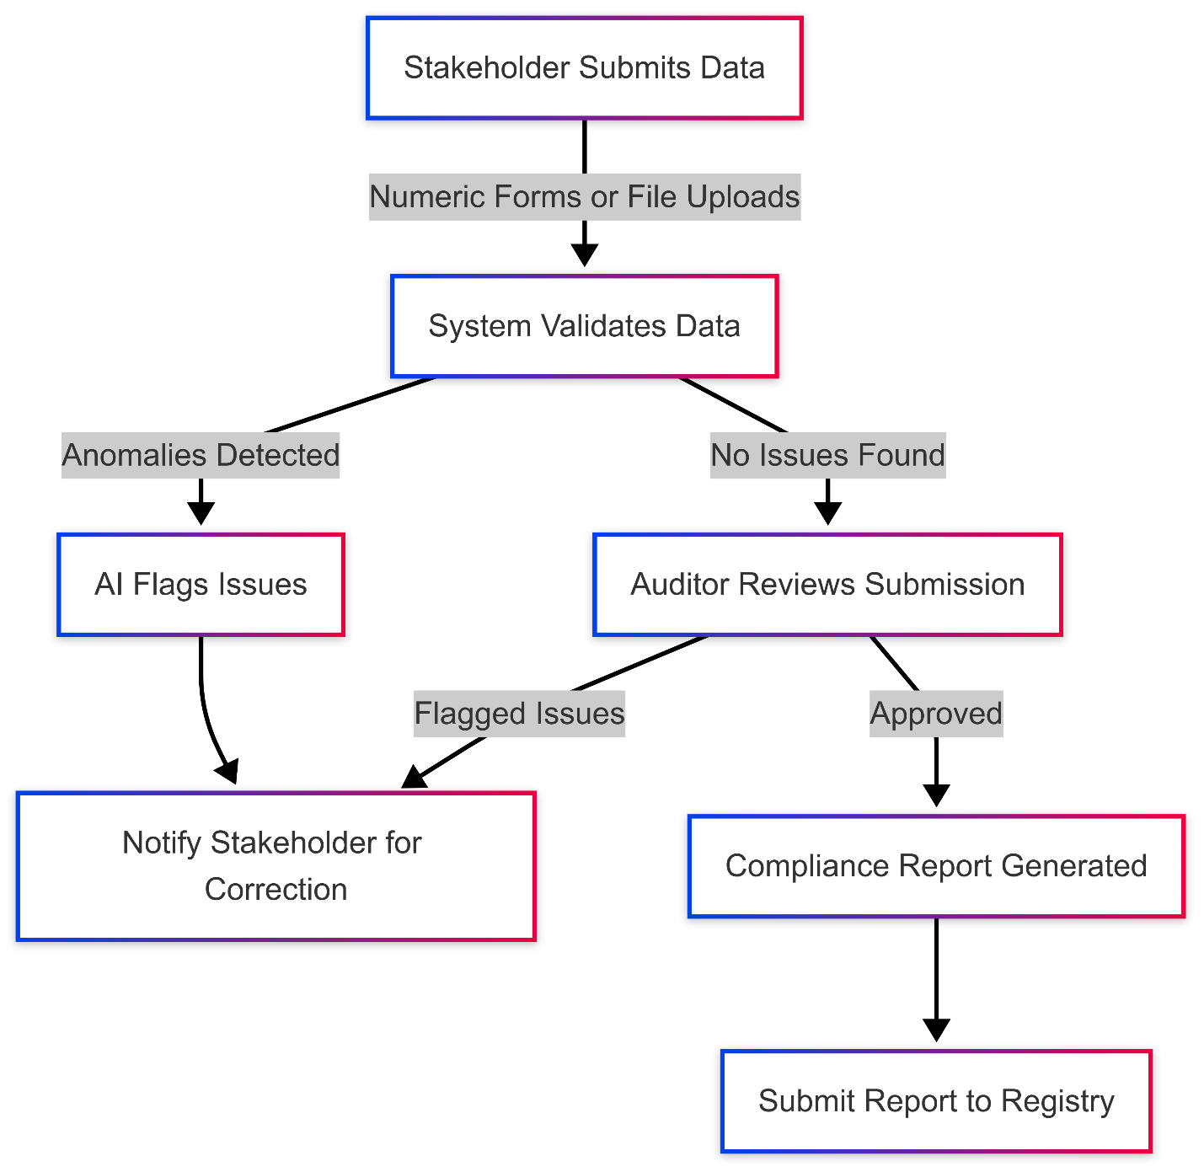

### **Phase 2: AI-Driven Enhancements (6–12 Months)**

#### **Key Deliverables**

1. **Advanced AI Models**
   1. **Enhanced Anomaly Detection**: Machine learning models to detect outliers in both numeric and document-based data.
   2. **Document Analysis with NLP**: Automate the extraction of key data (e.g., emissions factors, project descriptions) from uploaded documents.
2. **Predictive Analytics**
   1. Forecast emissions reductions based on historical data and project parameters.
   2. Identify trends and make recommendations for project improvements.
3. **Improved Dashboards**
   1. Real-time alerts for anomalies, compliance risks, or missing data.
   2. Predictive insights and visualizations for stakeholders and auditors.
4. **Process Automation**
   1. Automate risk assessments and focus auditor attention on high-risk projects.
   2. Use adaptive checklists tailored to project types.
5. **Website Expansion**
   1. Develop **case studies** to showcase successful projects verified by AAST.
   2. Implement **contact forms and chatbots** for stakeholder inquiries.

### **Phase 3: Advanced Automation and Integration (12–24 Months)**

#### **Key Deliverables**

1. **Integration with IoT**
   1. **IoT Sensors**:
      1. Integrate IoT devices to monitor real-time emissions (e.g., industrial sensors measuring CO₂ output).
      2. Automate data ingestion from IoT devices into the verification system.
2. **Smart Contracts**
   1. Use blockchain-based smart contracts to automate compliance workflows.
   2. Example: Trigger automatic approval once all submission requirements are met.
3. **Carbon Market Integration**
   1. APIs for submitting compliance reports directly to platforms like Verra and Gold Standard.
   2. Automate the issuance of verified carbon credits.

## **Technology Stack**

|  |  |
| --- | --- |
| **Component** | **Technology** |
| **Frontend** | React.js for responsive user interfaces. |
| **Backend** | Python (FastAPI/Django) for scalable APIs. |
| **Database** | PostgreSQL for structured data and AWS S3 for document storage. |
| **AI Models** | PyTorch or TensorFlow for anomaly detection and NLP processing. |
| **Visualization** | Plotly Dash for dashboards and Google Earth Engine for geographic data analysis. |
| **IoT Integration** | MQTT protocol and IoT platforms (e.g., AWS IoT Core) for emissions monitoring. |
| **Satellite Imagery** | Google Earth Engine, Sentinel-2, or Landsat for land-use analysis. |
| **Blockchain** | Ethereum and Solidity for smart contracts. |

## **Appendix: Terms and Concepts**

|  |  |
| --- | --- |
| **Term** | **Definition** |
| **VVB** | Validation/Verification Body - An entity that validates and verifies carbon project claims. |
| **Satellite Imagery** | Images from satellites used for land-use verification and change detection (e.g., deforestation tracking). |
| **IoT Sensors** | Internet-connected devices that monitor real-time data, such as emissions or energy usage. |
| **Smart Contracts** | Self-executing programs on a blockchain that automate workflows based on predefined conditions. |
| **NLP (Natural Language Processing)** | AI technology that processes text to extract relevant information, such as emissions factors or project details. |
| **Carbon Registry** | Platforms like Verra or Gold Standard where carbon credits are issued, tracked, and traded. |